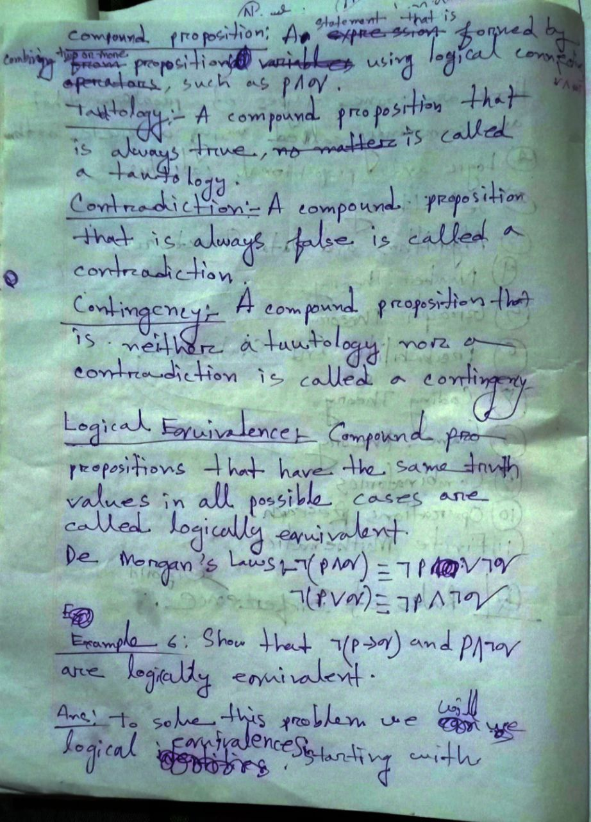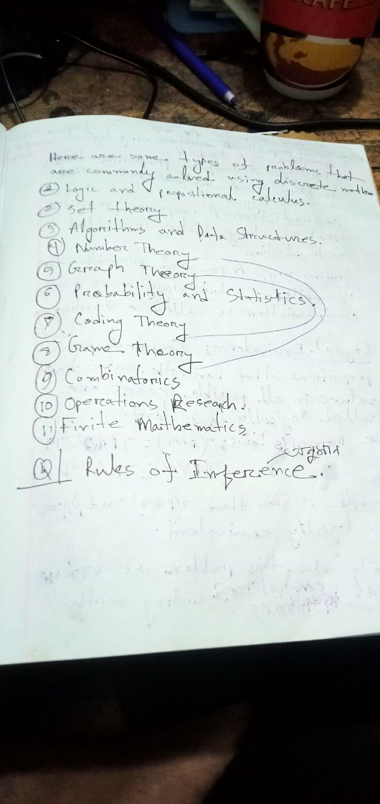

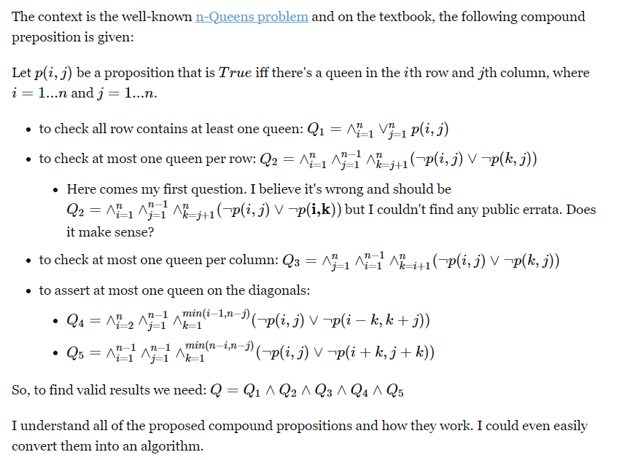

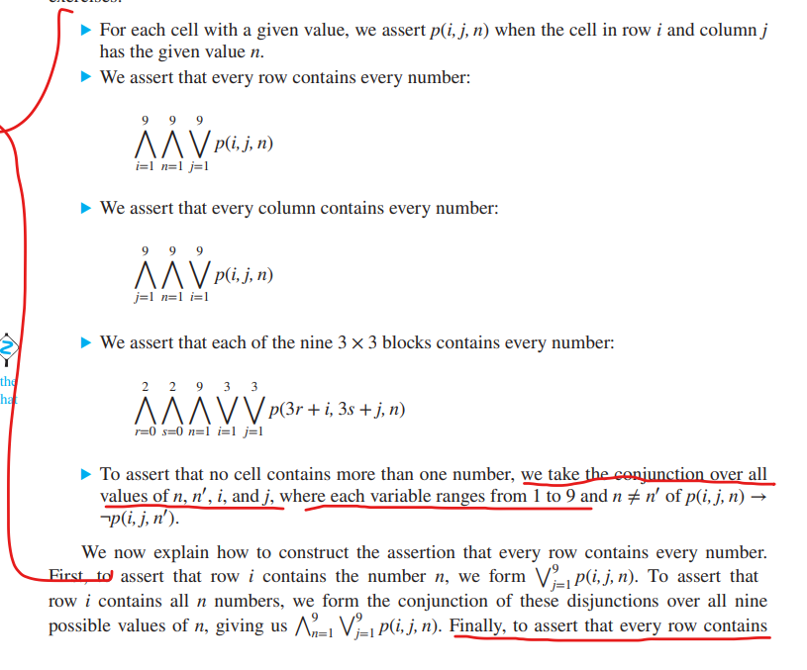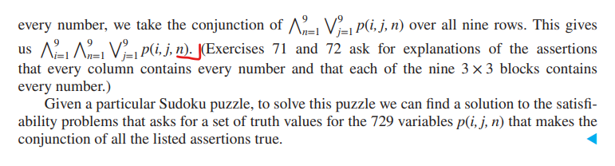

Definition of rules of inference?

In logic, rules of inference are like blueprints for constructing valid arguments. They provide guidelines for deriving new statements (conclusions) from already established ones (premises), ensuring those conclusions logically follow from the truth of the premises.

Modular arithmetic is a system of arithmetic that focuses on remainders after division by a fixed number, called the modulus (denoted by n). It's like a clock that "wraps around" when it reaches a certain point.

Key Concepts:

Modulus (n): The fixed number that determines the "cycle" or "wrap-around" point.

Congruence: Two integers a and b are congruent modulo n if they have the same remainder when divided by n. We write this as a ≡ b (mod n).

Modulo Operator (%): The modulo operator gives the remainder of a division. For example, 17 % 5 = 2 because 17 divided by 5 leaves a remainder of 2.

